Elior Bilow
Recitation 2 Problem – Steam Tunnels.
MEGN471 – CSM
2022-01-31

Assume steady state and 1D for the following problems.
1.
Mines uses steam from the Coor’s factory to heat the buildings. The steam is transported through a network of tunnels that travel under the sidewalks at Mines (so that the snow gets melted). According to ASHRAE, the temperature difference between the top of the concrete that’s exposed to the surface (T2) and the bottom of the concrete that’s exposed to the steam tunnels (T1) should be no greater than 18ºC (T1 - T2 < 18ºC). What’s the maximum thickness that the concrete can be? Assume these tunnels provide a uniform 1200 W/m² and that the thermal conductivity of the concrete is 1.4 W/(m*K).

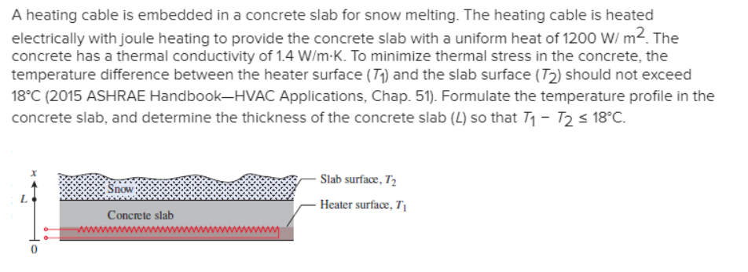

2.
CU isn’t fortunate enough to have a beer factory to heat up their buildings and sidewalks. We’ll assume they use a pad underneath their sidewalks to heat them up. What is the maximum temperature in the heating pad? The dirt surrounding the pad has a thermal conductivity of 0.3 W/(m*K). The thermal conductivity of the heating pad is 50 W/(m*K) and it’s 5mm thick. Use the values you calculated in the first part of this problem.

